Q1.

(a)

y=10t-1.86t2

Velocity=

1. For time interval [1,2],

Average velocity =

= 4.42 m/s

1. For time interval [1,1.5],

Average velocity =

= 5.35 m/s

1. For time interval [1,1.1],

Average velocity =

= 6.095 m/s

1. For time interval [1,1.01],

Average velocity =

= 6.261 m/s

1. For time interval [1,1.001],

Average velocity =

= 6.279 m/s

(b)

v(t)= .=10-(2\*1.86t)

Instantaneous Velocity at t=1,

v(1)=10-(2\*1.86\*1)

= 6.28 m/s

Q2.

(a)

s = 2sin(πt)+3cos(πt)

Velocity=

1. for[1,2],

Average velocity =

=

=6 cm/s

1. for[1,1.1]

Average velocity = -4.712 cm/s

1. for[1,1.01]

Average velocity = -6.134 cm/s

1. for [,1.001]

Average velocity = -6.268 cm/s

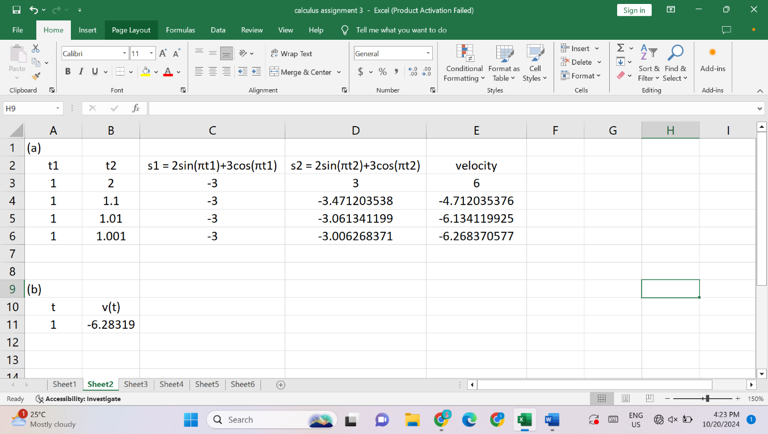

(b)

s = 2sin(πt)+3cos(πt)

*v(t)=*

*. =*2π cos(πt)-3π sin(πt)

instantaneous velocity when t=1,

. *=*2π cos(π\*1)-3π sin(π\*1)

Since cos(π)=−1 and sin(π)=0

. *=*2π \*(-1)-3π\*0

= -2π

-6.283 cm/s

Q3.

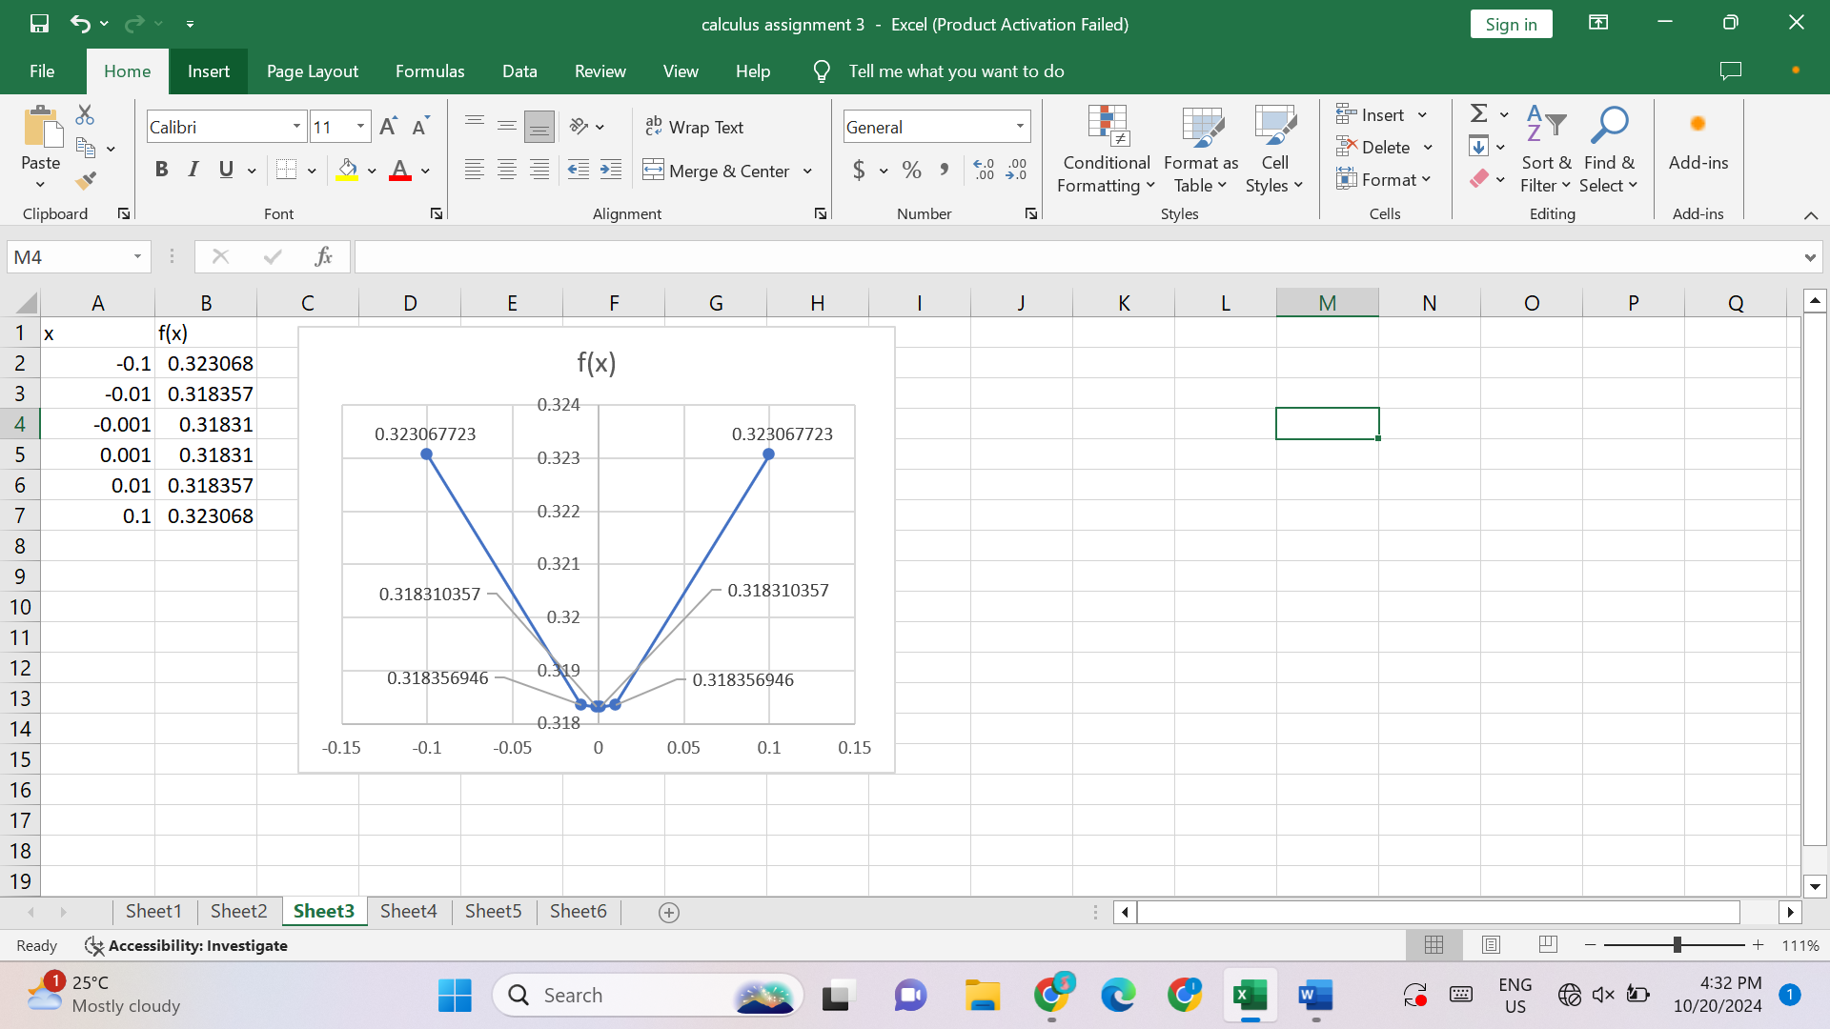

1. f(x)=

f(-0.1)= 0.32 (two decimal places)

f(-0.01)= 0.32

f(-0.001)= 0.32

f(0.001)= 0.32

f(0.01)= 0.32

f(0.1)= 0.32

1. 0.3183

Q4.

1. x=0.00001

(1+0.00001)1/0.00001 = 2.71827

So,

2.71827 e



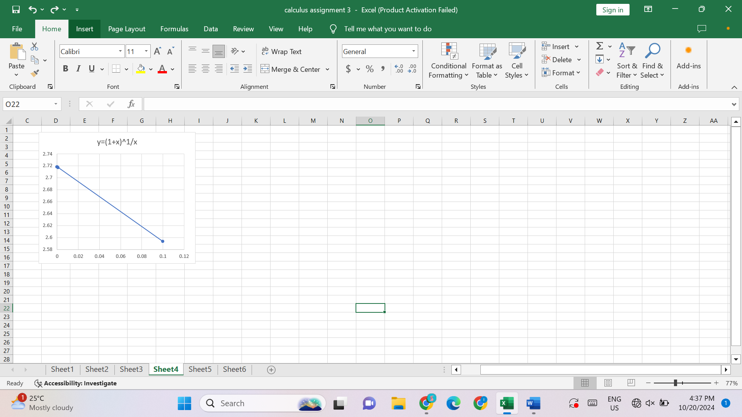

Q5.

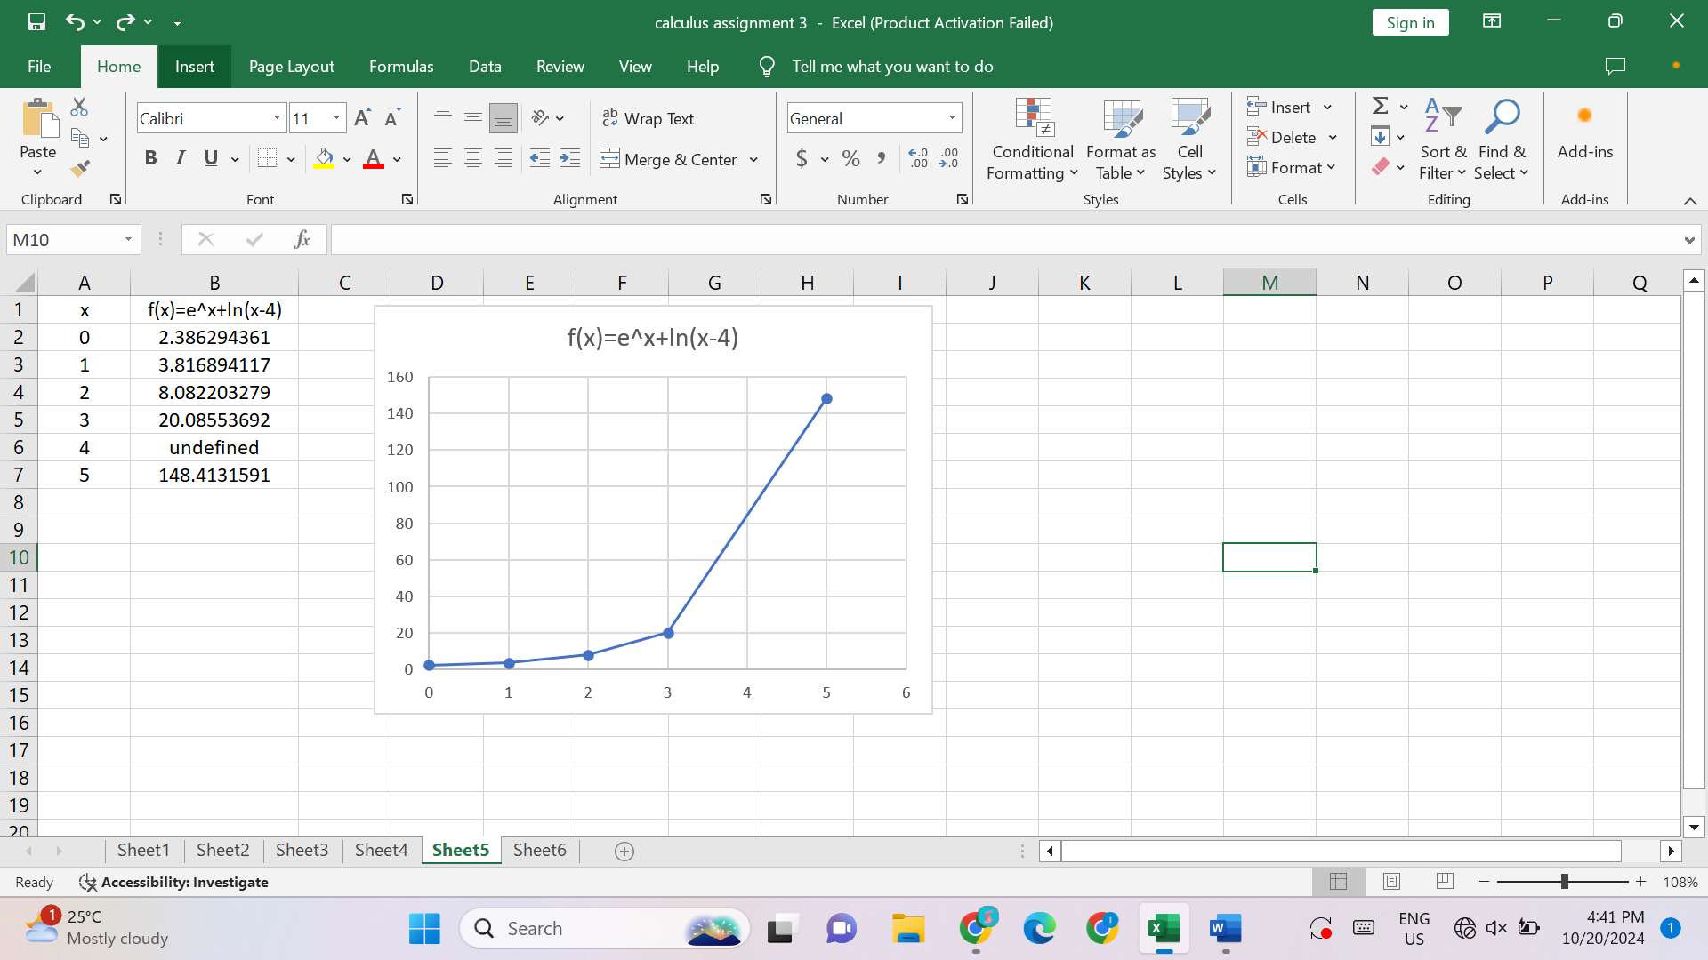

ln |x - 4| becomes undefined at x=4 since ln(0) is undefined.

To get a better representation of the function,

We can use a smaller increment for x, and can skip the undefined point to graph.

Q6.

(a)

f(x)=

f(0.9)=5.280931738

f(0.99)= 5.925312187

f(0.999)= 5.992503125

f(1.001)= 6.007503125

f(1.01)= 6.075312812

f(1.1)=6.781557287

= 6

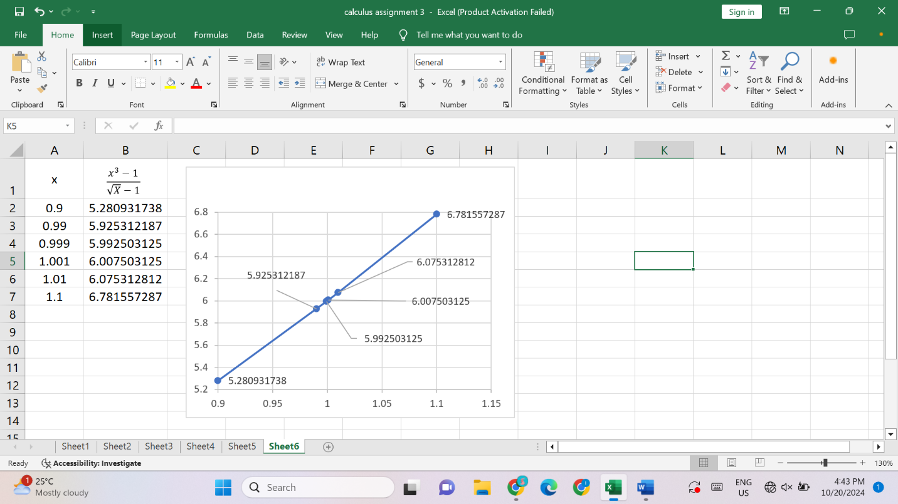

(b)

To find the value of x that gives 5.5 and the value of x that gives 6.5

f(0.931385) = 5.5

f(1.064900) = 6.5

Therefore, x has to be within [0.931385, 1.064900] for the function to be within a distance 0.5 of its limit as x goes to 1.